Levarski, Z. *et al.* (2014) ‘High-level expression and purification of recombinant human growth hormone produced in soluble form in escherichia coli’, *Protein Expression and Purification*, 100, pp. 40–47. doi:10.1016/j.pep.2014.05.003.

# Introduction

Levarski, Z. *et al.* have prior experience with cloning E. coli bacteria to produce an antimicrobial peptide named LL-37 (Krahulec et al., 2010). Their current endeavor involves adapting this system to yield hGH. Earlier studies by Shin, N.-K. et al. (1998) pinpointed the hGH hormone consists of 191 amino acid segments that arrange into a four-helix structure, linked by two disulfide connections. Given its therapeutic attributes, growth hormone can be used to treat conditions like dwarfism, bone injuries, skin burns, and bleeding ulcers. As hGH isn't glycosylated, expression systems like Escherichia coli are typically chosen for producing recombinant hGH, as noted by Shin, N.-K. et al. (1998).

# Description of what was done.

**What factors were considered when deciding on the vector and/or host system?**

The selection of the pJK100EK-hGH vector and E. coli as the host system was strategic for effective protein expression. E. coli produces recombinant proteins as insoluble aggregates, particularly when the protein is of non-bacterial origin. To navigate this challenge, the researchers employed a T7-based expression system to yield high quantities of a soluble thioredoxin-hGH (Trx-hGH) fusion protein. The T7 promoter, derived from the T7 bacteriophage, plays a pivotal role by facilitating robust and stringently regulated gene expression, minimizing unwanted background activity (Studier & Moffatt, 1986). The 6X Histidine tag simplifies purification. Given its strong affinity for certain metal ions, it allows for efficient capture and purification of the protein through metal-affinity chromatography.

**What factors were considered when deciding on the purification technique?**

The purification for Trx-hGH encompasses multiple steps to maximize purity and yield.

* Cell Disruption via Sonication: While efficient, the researchers had to be wary of potential heat denaturation. The use of sonication suggests a preference for thorough cell disruption even if it requires careful monitoring to prevent overheating.
* Affinity Chromatography: Given the 6X Histidine tag on Trx-hGH, this choice was optimal. The strong and specific binding between the tag and the column ensures high selectivity, which is crucial for the isolation of the target protein.
* Anion-exchange Chromatography: The choice to include this step speaks to the aim of achieving high purity. By exploiting differences in protein charge, this method further refines the protein sample.
* Enterokinase Cleavage: This step emphasizes the aim to retrieve hGH in its most native form. While it introduces additional costs, the benefits of obtaining a clean, tag-free protein justify the choice.
* Dialysis and Ultrafiltration: Ensure the protein is in the desired buffer and concentration. Their inclusion indicates the thoroughness of the purification process.

**Figure showing the steps used for the cloning, expression, and purification of the protein**.

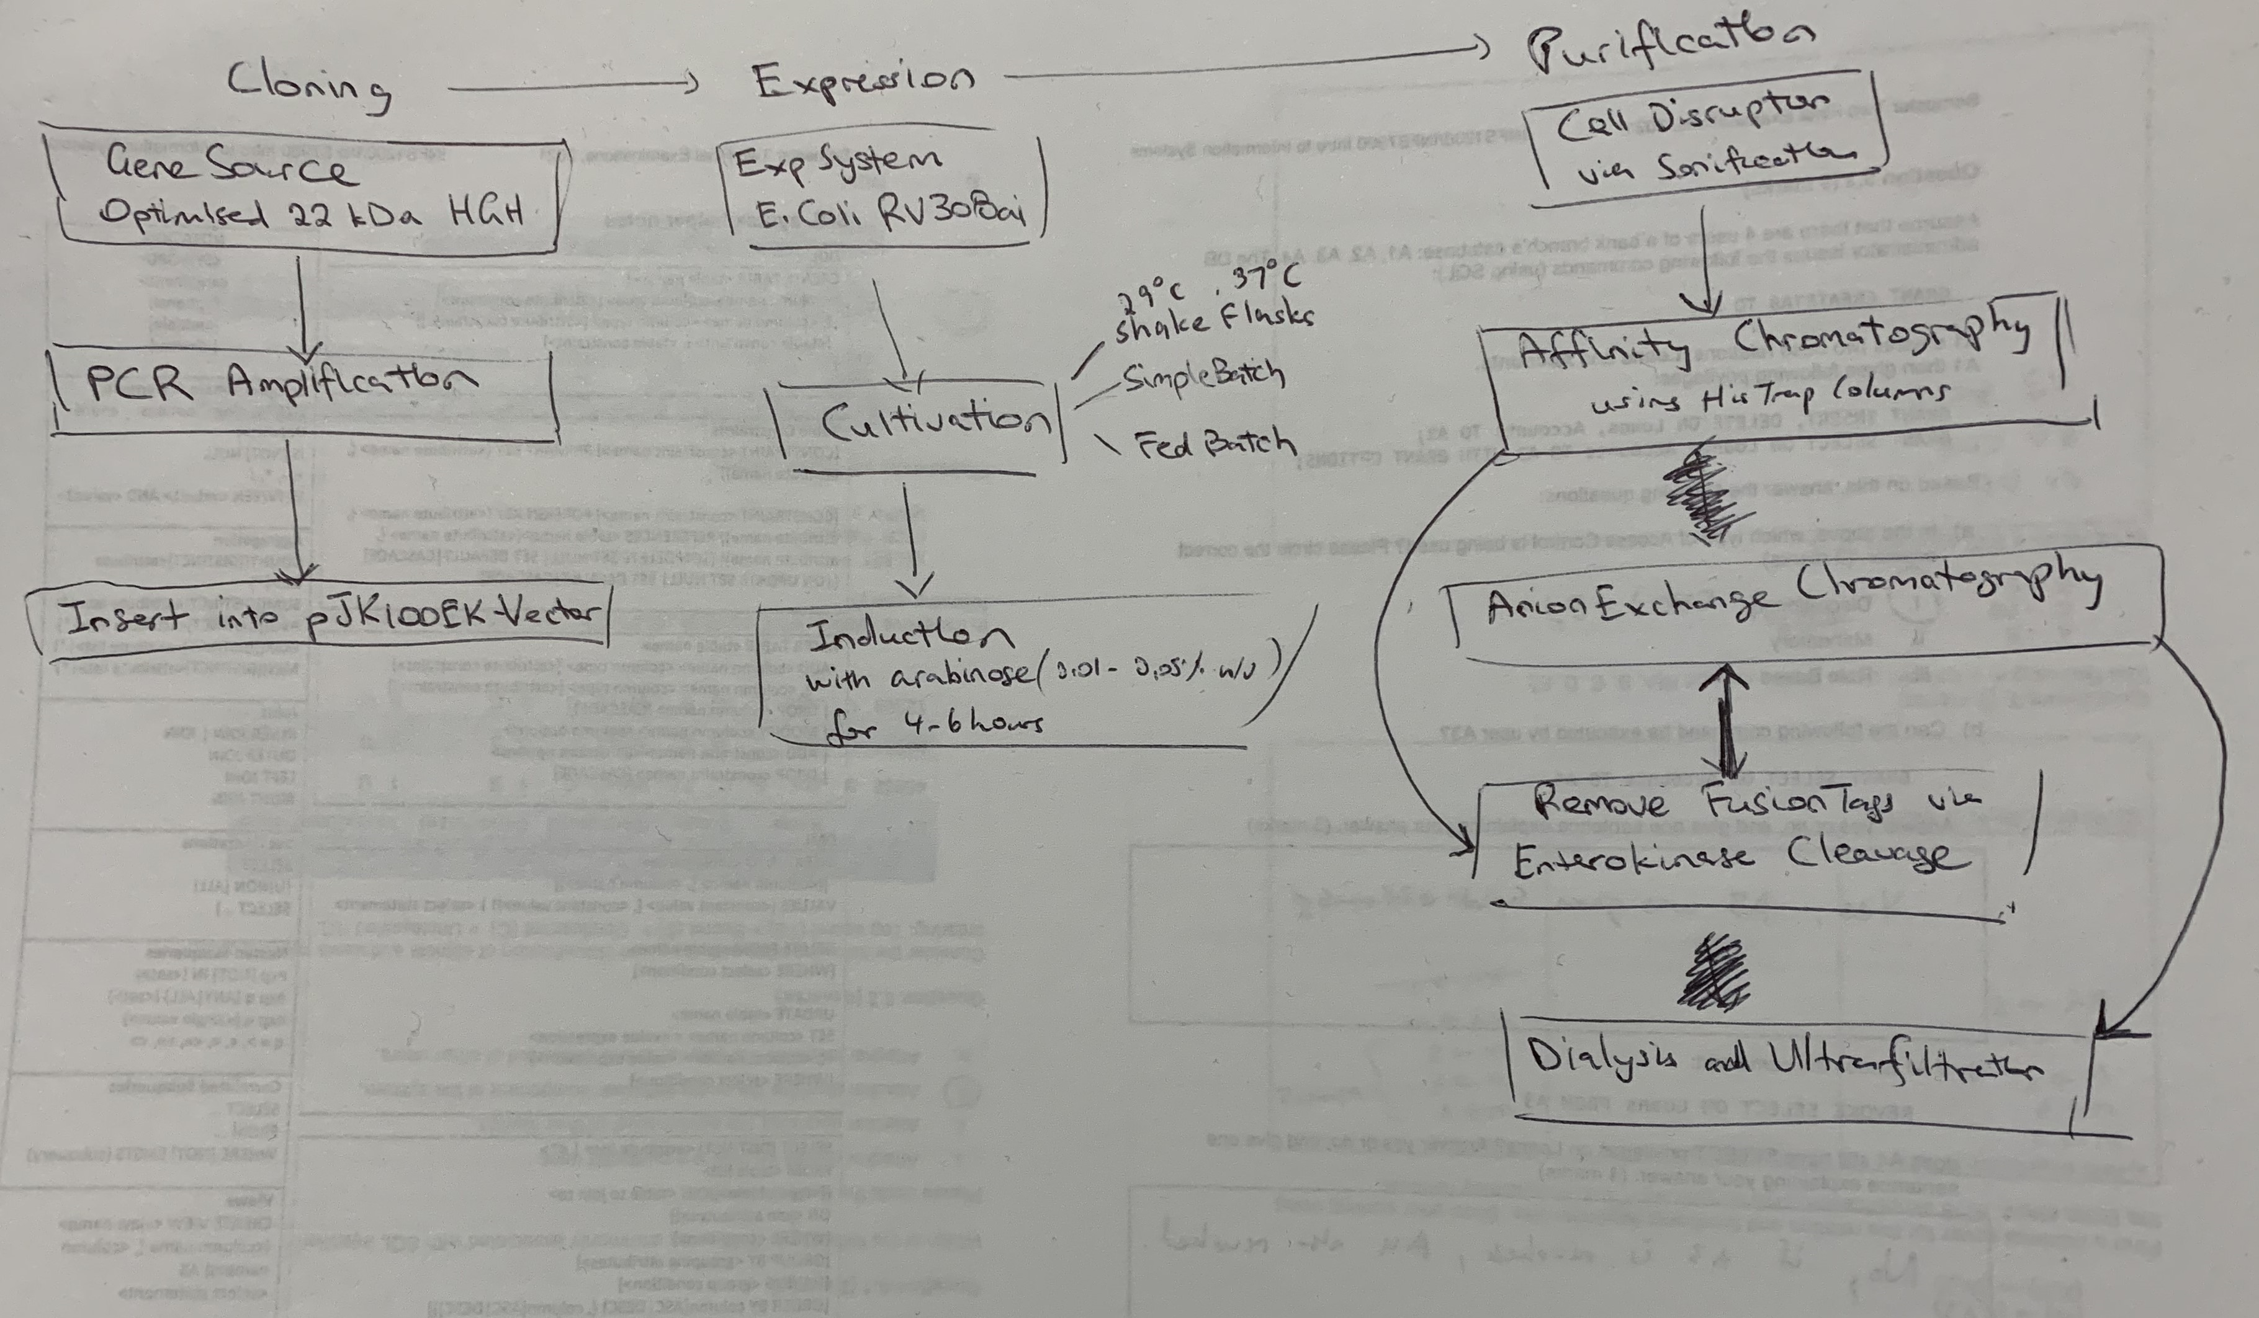

**Factors considered in the optimization of expression.**

The choice of bacterial strain can profoundly influence expression levels, protein solubility, and the overall yield of the protein. For general cloning and plasmid maintenance, the DH5a strain was employed. In contrast, the RV308ai and BL21(DE3) strains served as host strains dedicated to protein expression. The study underscored three distinct cultivation modes: the basic batch mode, the fed-batch mode, and flask culture. Each mode was tested at two temperatures, specifically 29°C and 37°C. The incorporation of multiple cultivation modes and temperature variations speaks to the researchers' meticulous approach to identify the most favorable environment for protein expression.

**How was expression monitored/measured/compared?**

Expression was chiefly monitored via densitometric analysis of SDS-PAGE gels, allowing visualization of the protein's presence and purity. (Patra, A.K. *et al.*, 2000) The Reversed phase-HPLC further confirmed the hGH protein's purity.

**The results of the expression**

The product distribution after cell disruption varied based on the temperature. At 37°C, 60% aggregated into inclusion bodies, whereas at 29°C, about 95% remained soluble. (Fig. 1).

The expression rate in flask cultures reached 9% of total cell protein (TCP) 1h after induction, 15.3% after 2h, 20% after 3h and 23.2% of TCP 4h after induction with an average OD600 of 6.5 (Fig. 2). Shake-flask cultures yielded expression rates on average 23.3% of total cell proteins (TCP), followed by 19.5% of TCP during batch fermentation and 14.4% during fed-batch.

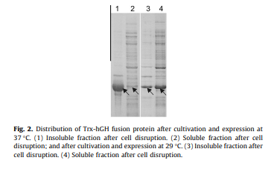

Figure 1, SDS-PAGE gel of Trx-hGH expression, from Figure 2 of Levarski, Z. et al. 2014(2)

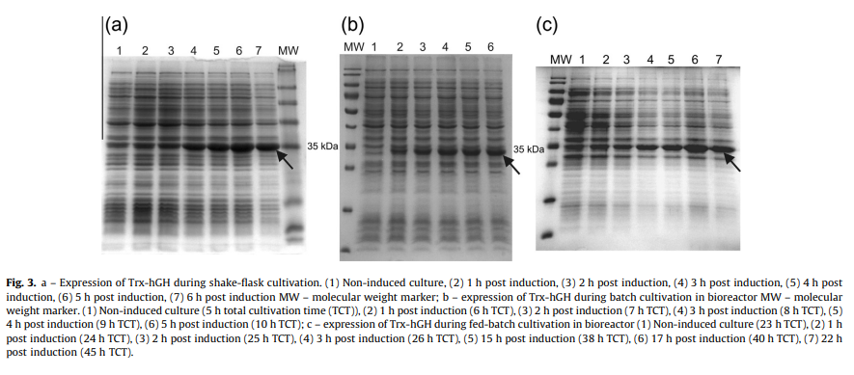

Figure 2, SDS-PAGE gel of Trx-hGH expression, from Figure 3 of Levarski, Z. et al. 2014(2)

**A comment on the yield of protein after purification**

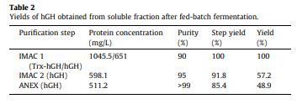

Figure 3 taken from Table 2 of Levarski, Z. *et al.* 2014(2)

Affinity Chromatography purified the Trx-hGH, resulting in a >90% pure product. Enterokinase (hEK) cleaved the fusion protein with an efficiency of 88–94%. A second IMAC round removed residual enterokinase, Trx-His6, and other contaminants. Following anion-exchange chromatography, the resultant hGH exhibited a purity of >95% on tge SDS–PAGE gel. after two IMAC rounds and one anion-exchange chromatography step, Reversed-phase HPLC analysis showed hGH with >99% purity as determined by peak integration.

# Conclusion

Levarski and colleagues embarked on a quest to optimize the production of recombinant human growth hormone (hGH) in E. coli, a challenge that holds significant promise for biotechnological applications. Using a T7-based expression system augmented with a suite of purification techniques, including IMAC and anion-exchange chromatography, provided high purity yields. This case study exemplifies the intricate dance of molecular biology, where each step—be it the choice of cultivation mode, or purification technique plays a pivotal role in the final yield. The successful yield achieved by Levarski et al. can be used to treat growth hormone conditions such as dwarfism in the future.

# Annotated Bibliography

Krahulec, J. *et al.* (2010) ‘High level expression and purification of antimicrobial human cathelicidin LL-37 in escherichia coli’, *Applied Microbiology and Biotechnology*, 88(1), pp. 167–175. The pJK100-EK vector and E.coli cloning techniques from the chosen case was inspired by this study.

Levarski, Z. *et al.* (2014) ‘High-level expression and purification of recombinant human growth hormone produced in soluble form in escherichia coli’, *Protein Expression and Purification*, 100, pp. 40–47. doi:10.1016/j.pep.2014.05.003.

Patra, A.K. *et al.* (2000) ‘Optimization of inclusion body solubilization and Renaturation of recombinant human growth hormone from escherichia coli’, *Protein Expression and Purification*, 18(2), pp. 182–192. This study explores multiple methods for minotoring the expression of Recombinant Human Growth Hormone from E.coli

Shin, N.-K. *et al.* (1998) ‘High-level production of human growth hormone in escherichia coli by a simple recombinant process’, *Journal of Biotechnology*, 62(2), pp. 143–151. This previous study is very similar to the chosen study with similar methods and cultivation modes.

Studier, F.W. and Moffatt, B.A. (1986) ‘Use of bacteriophage T7 RNA polymerase to direct selective high-level expression of cloned genes’, *Journal of Molecular Biology*, 189(1), pp. 113–130. This study explores the importance and uses of the T7-based expression system.